For ebayAppium: This project is to test calculator function.

For current Project: We are using

1. Appium
2. Android SDK
3. Emulators
4. Java 8
5. Maven
6. TestNG

For Data handling we are using Apache POI

Under Package: **package** com.sm.name.ebayAppium; we have 2 classes

1. BaseClass.java
2. Basic.java

**BaseClass:** Under base class we define @beforeMethod and @AfterMethod.

1. @BeforeMethod : We did the driver initialization and all the test will call 1 driver through extending this class also we define the desired capabilities of appium

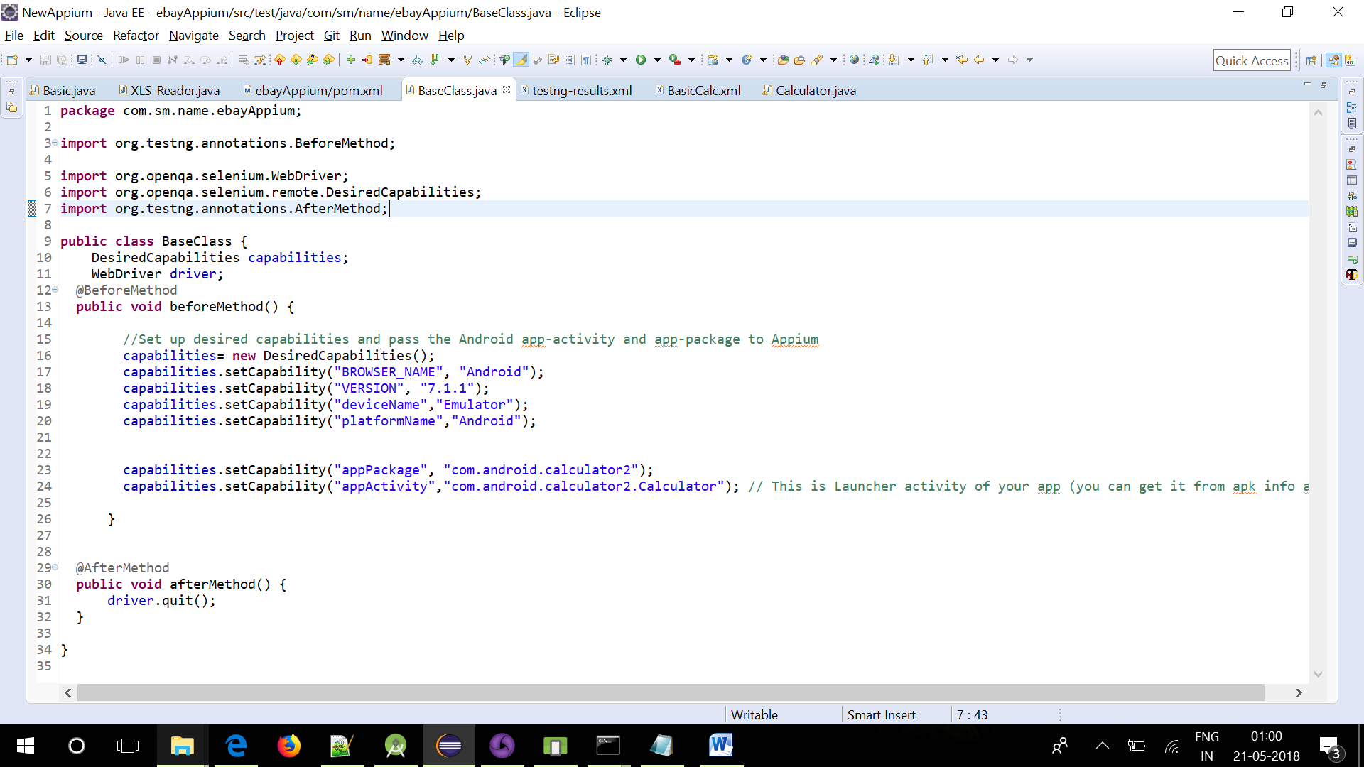

1. @AfterMethod: We are quitting the driver

**BasicCalc.java**: In this we just perform the operation and validate the result.

We add 5+4=9 through calculator and validate the result

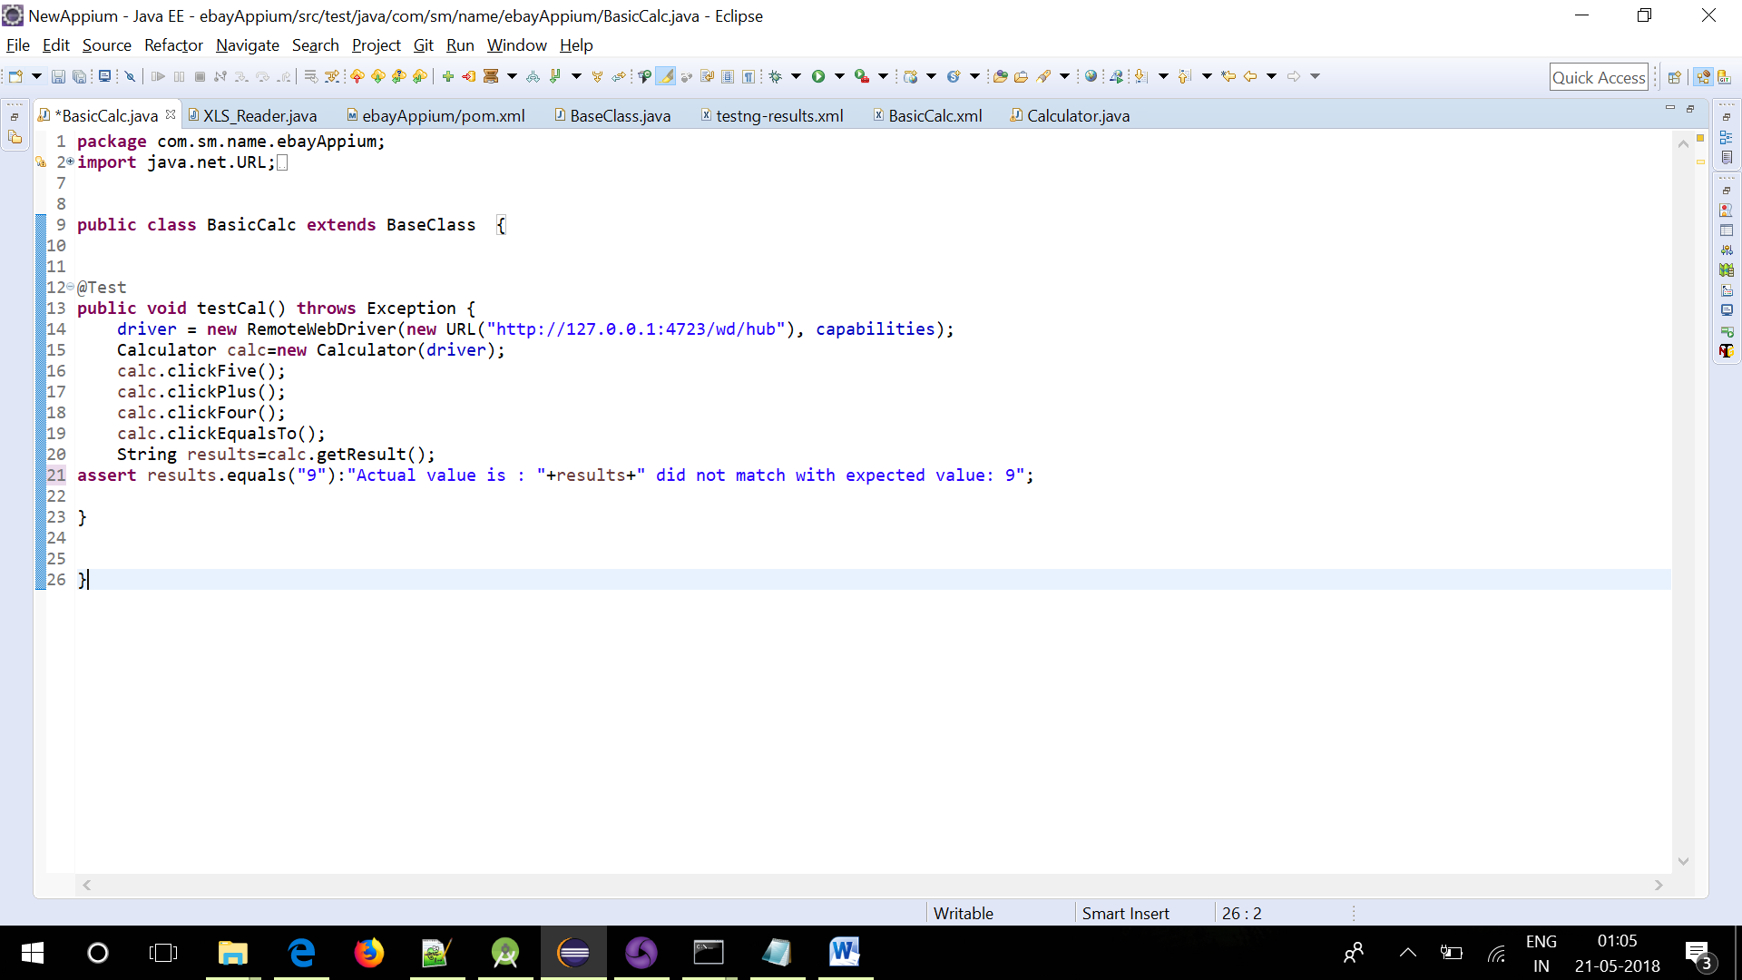

PageFactoryModel:

The calaculator xpath defined through page factory as you can see in BasicCalc.java is just importing the function from calculator class that is under src.main.java, screenshot below:

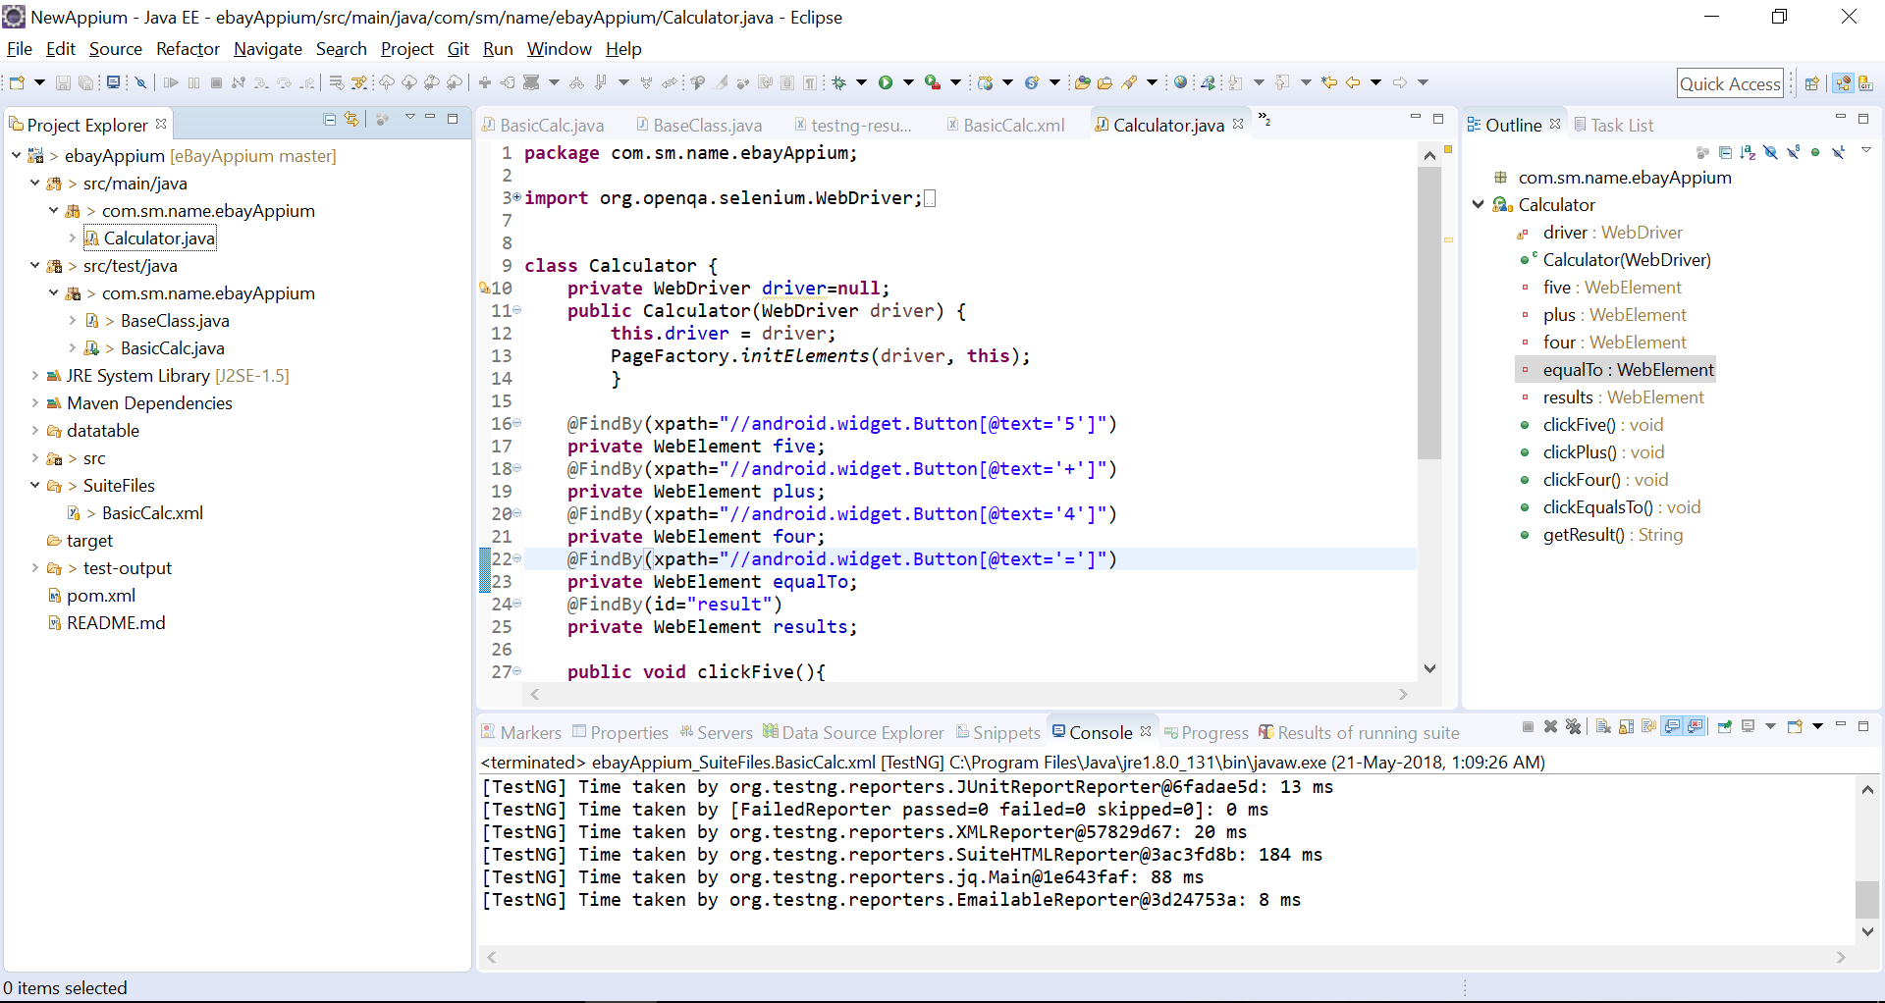

In this class we properly use the page factory model to define the elements also the actions they can perform

**Suite File: It present under SuiteFiles folder**

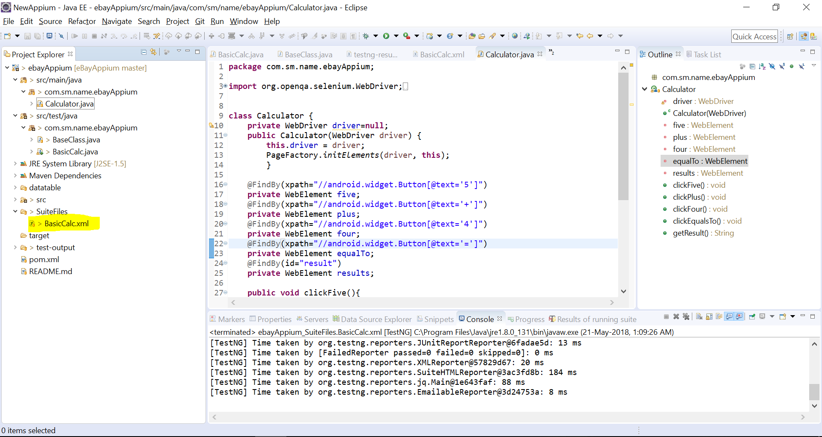

**Datahandling:** For excel handling we have resuable methods that stored under datatable folder and class name is **XLS_Reader.java**

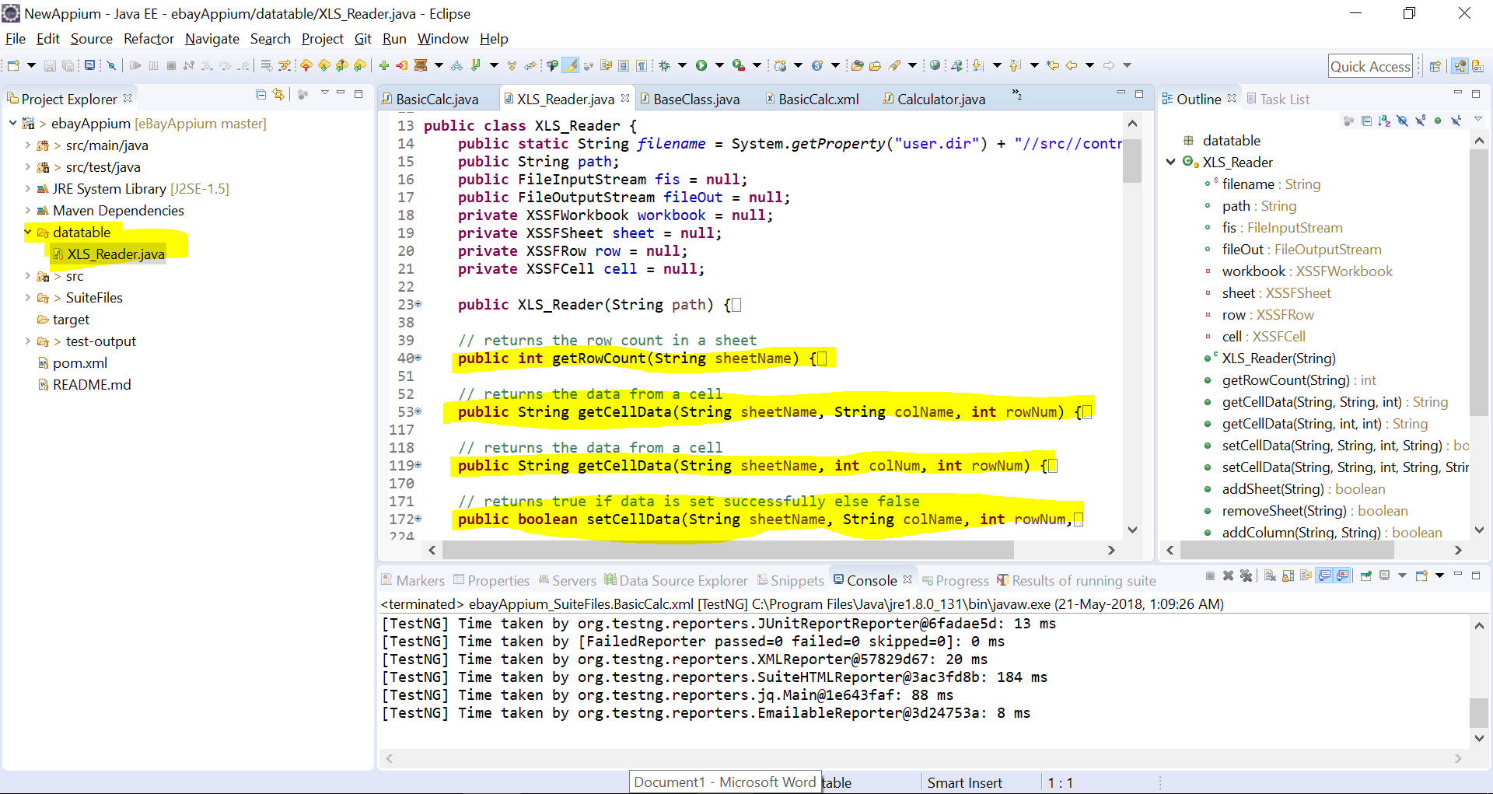

With multiple reusable method for excel handling like:

1. Getrowcount
2. getCellData
3. SetCellData
4. AddSheet
5. DeleteSheet

And many reusable method